**Auto Monitor and refresh**

Config Monitor Application:

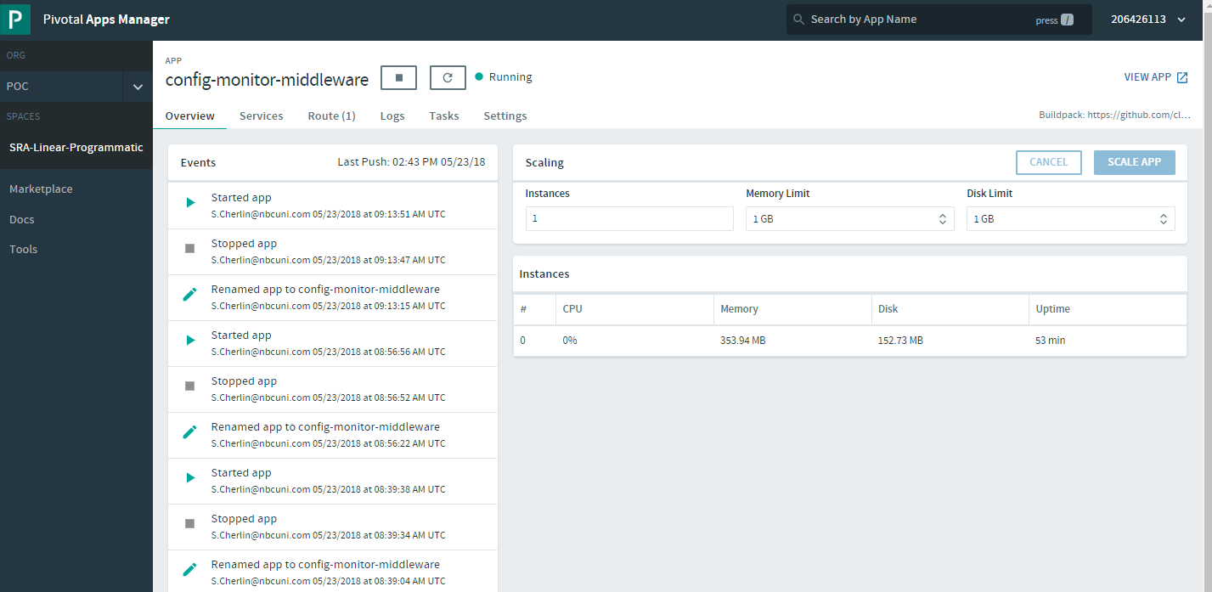

Client Application:

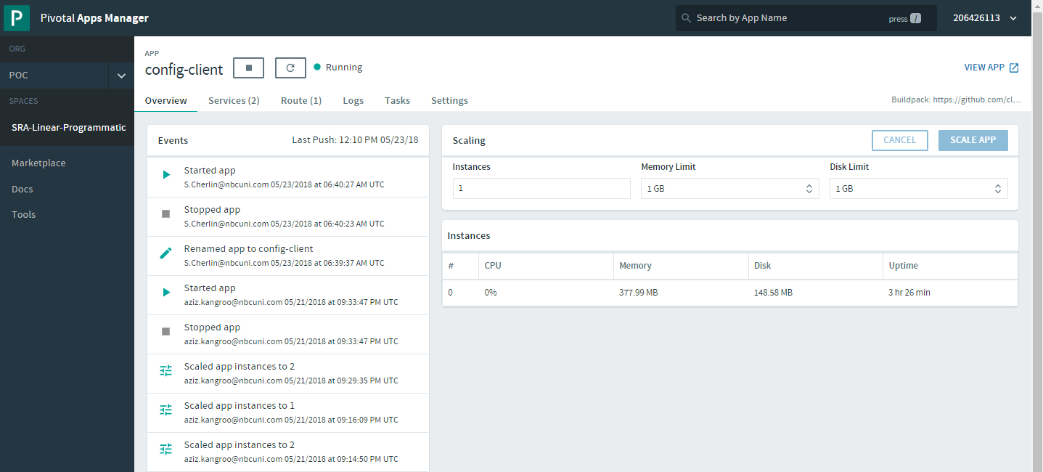

Source Code:

Repo URL : <https://github.com/123Ammar/ConfigServer-Monitor>

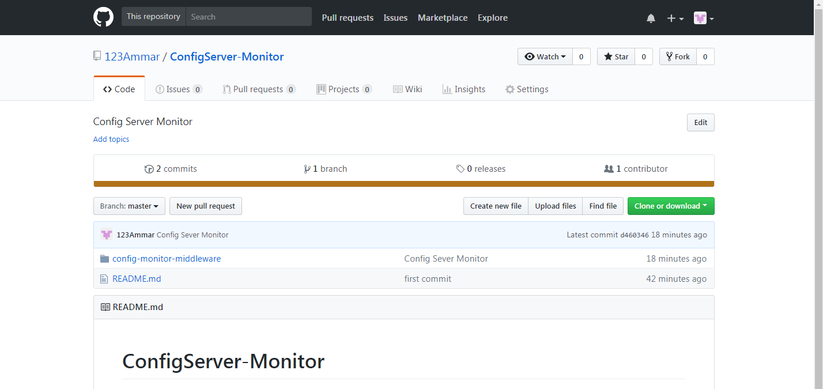

**configMonitorSQL.sql**

**Table is create for storing the App Name, App URL and env(branch)**

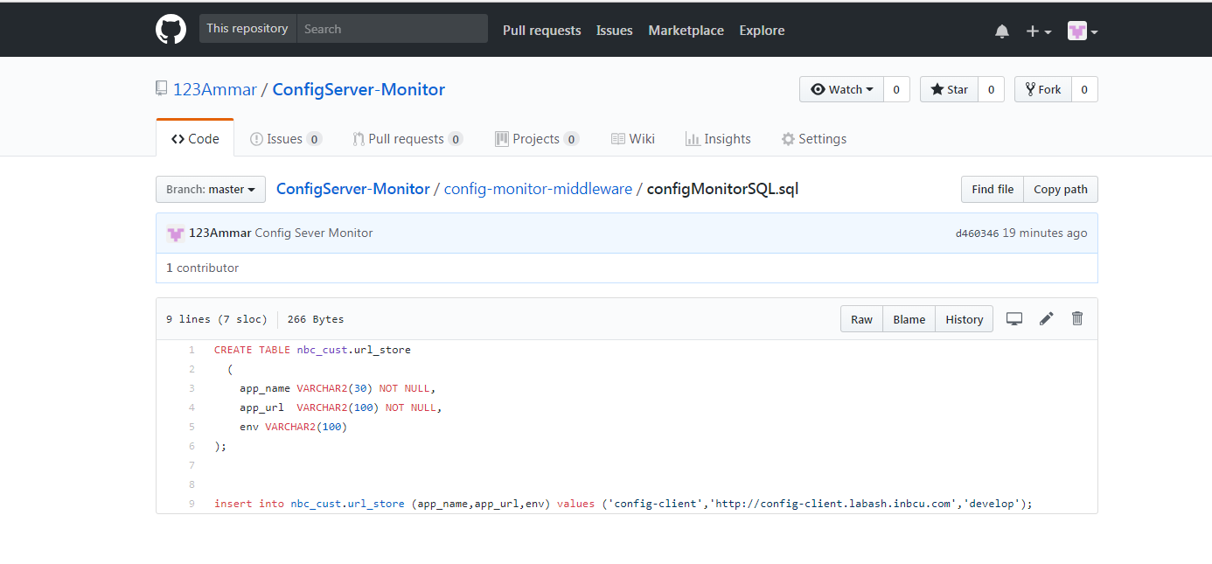

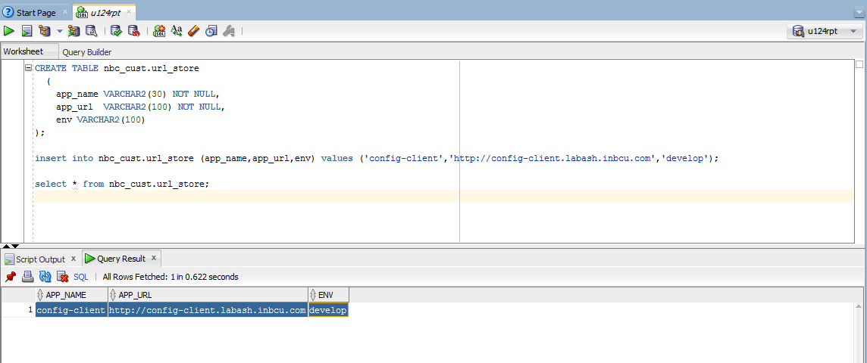

**Client Application :**

Properties is located in **adsales-config** **repo** and **config server** is pointing to **develop** branch

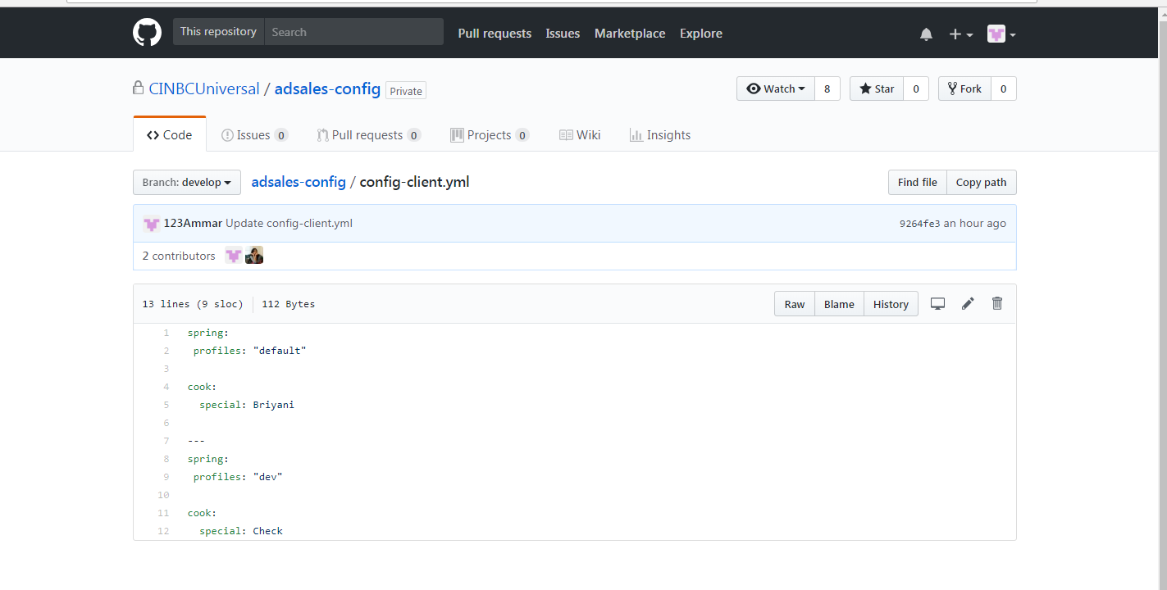

**Before**:

**URL** : http://config-client.labash.inbcu.com/test

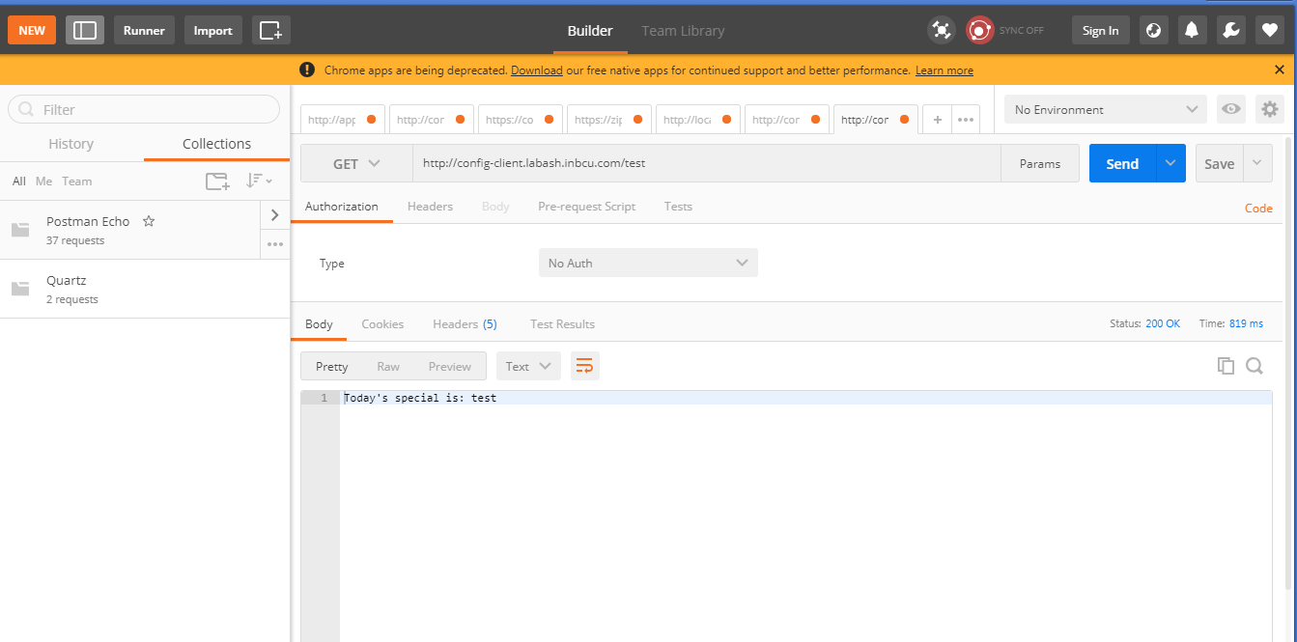

Modifying the config file:

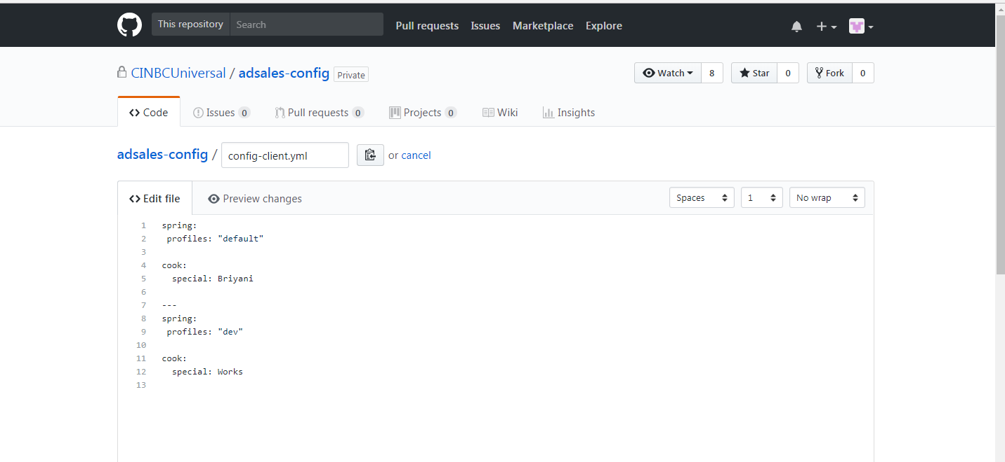

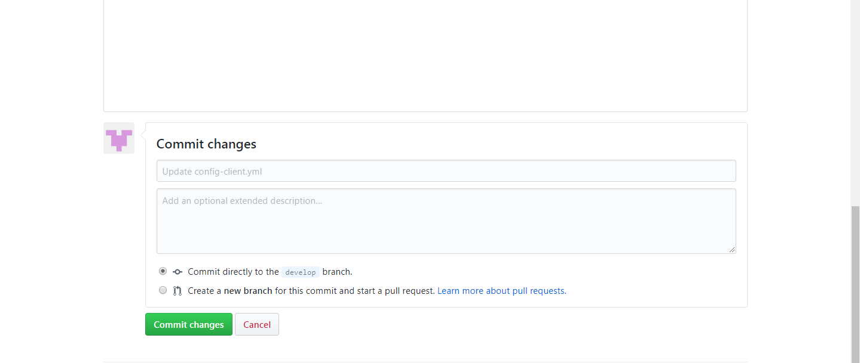

**Monitor Service Log:**

Shows that refresh happen

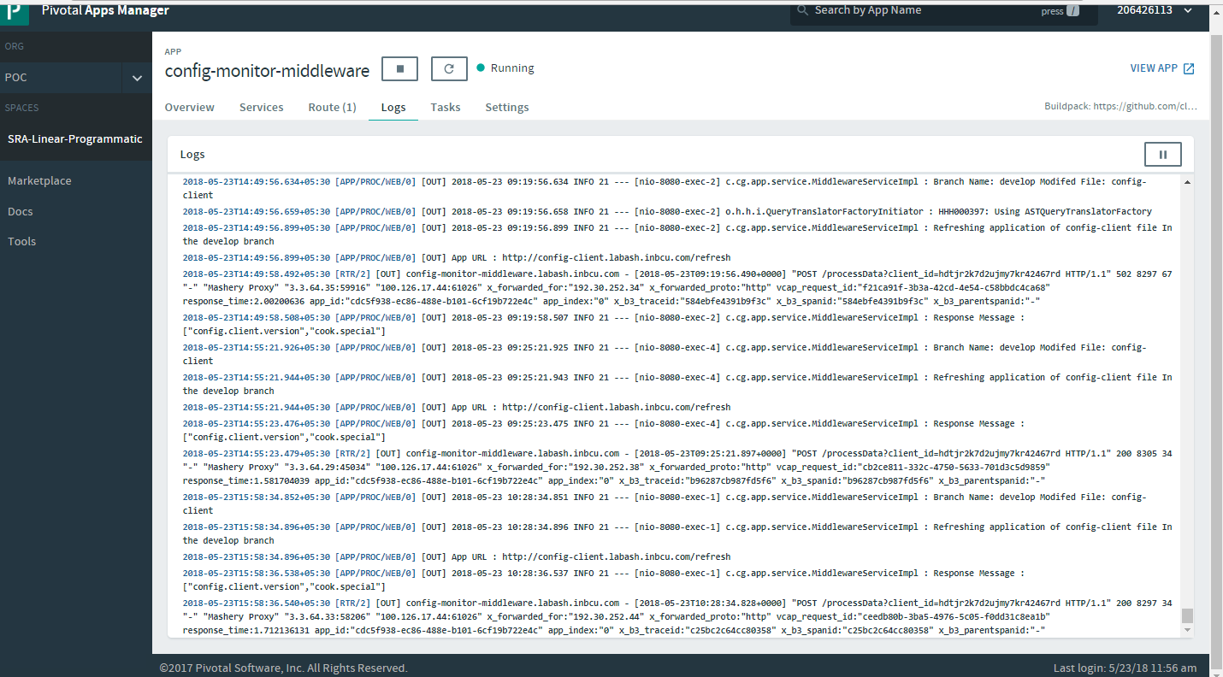

Accessing the Client Application:

Refresh happen automatically

